OSA-CT Ministry Report
November 2012: 10 babies were saved
78 surgical abortions Bridgeport
Since 1990: 2250 babies saved, 407 salvations
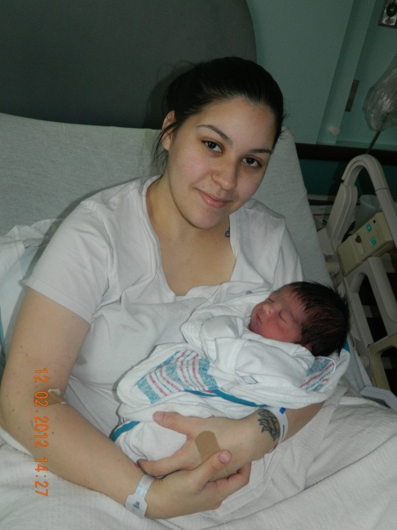
Frances gave birth to Nathan Louis on Dec. 1, 2012, 3:33 PM
He weighed in at 7 pounds 9 ounces at St Mary’s Hospital in Waterbury
Mom and Dad and three brothers our happy for the new baby’s arrival!
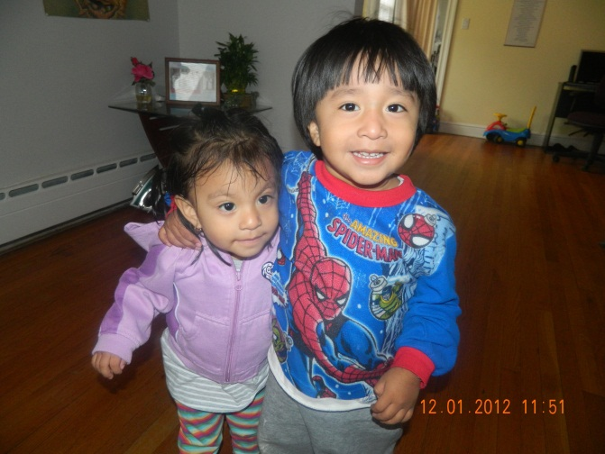
This is Diana (almost 2) a saved baby, with her brother.

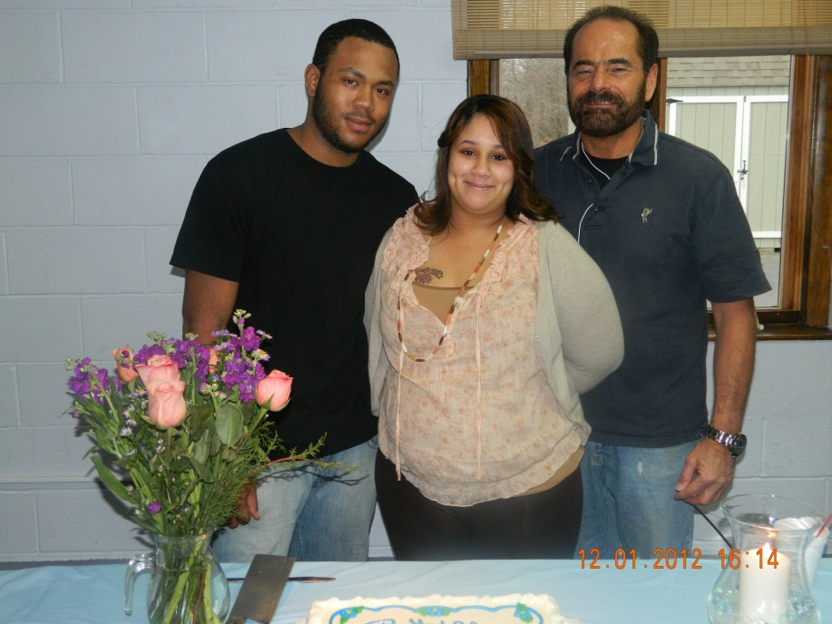
Pastor Loomer was there when Jolanda changed her mind at PP and he wanted to shower her with God's blessing with a baby shower at his church. Many Christians came to encourage and celebrate with Jolanda and Keyjaun because they chose life for their baby! Jolanda gave her life to Christ on 11/25/12 and we are praying for Keyjaun to do the same. She is due to have a baby boy in January.
Ebony is due to have twin boys on Dec 16th. We are still trying to find them a place to live. This past week six babies were saved! Praise the Lord. Two are a set of twins. Please join us at 3787 Main Street Bridgeport where we reach out to those who find themselves where they should not be. The schedule lately is Wednesdays and Saturdays 8 AM- 10 AM. Come and take a public stand against abortion. You can hold a sign, pray or distribute literature
Pastor Ed Martin from Georgia said “Let me make this perfectly straight, I never felt God calling me to do this work, nor do I consider it my vocation in life. THE KILLING OF THE UNBORN CHILDREN IS AN EMERGENCY, ALL I AM DOING IS RESPONDING TO THAT EMERGENCY. I would love to pastor a large church or run a huge ministry with a nice paycheck to boot. It is the emergency that puts me out on the street most days in front of a killing center to try to save these wonderful children.”
On Saturday Nov. 24th at PP, a young man Viren (16 yrs. old) was pleading for the life of his baby. His girlfriend was inside PP and she didn't want to come back out to talk with us. Carmen spoke to her extensively over the phone and pleaded with her to come out and talk with us. The young mom was afraid to tell her parents that she was pregnant and we encouraged her not to worry that and we would go with her to talk to her parents. She never came out. Jeff Christman counseled Viren and led him in the sinner’s prayer to receive Christ into his life. We gave him a bible and Jeff offered to bring him to church on Sunday. PTL
Jazmin stopped by to visit and say thank you for all the help she received from the ministry. She showed us pictures (above) of her twins. They are 8 years old now and doing well. Jazmin is so happy and thanks God for her children.
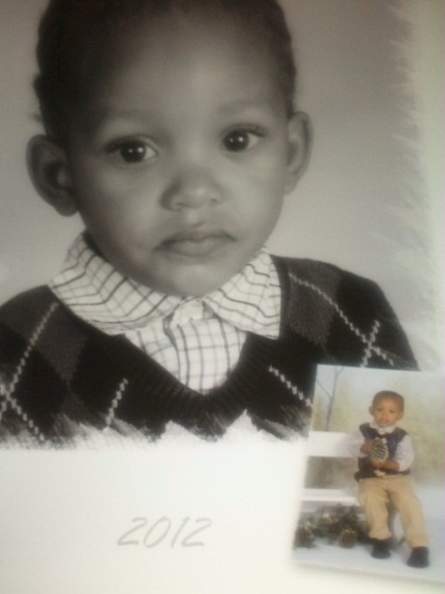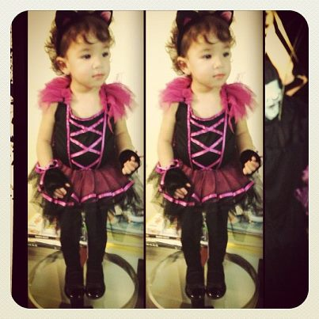
Here are two more ministry babies, AJ is two and Alesandra is one.
NEEDS: Diapers, wipes and Stop & Shop food cards needed continuously.
Thank you for your help, we cannot do this alone.
www.osaconnecticut.webs.com

