OPERATION SAVE AMERICA-CT
Count for June 2012: 124 babies killed by surgical abortion
9 babies spared when moms changed their mind
37 babies saved so far this year / 2221 babies saved since 1990
404 salvations since 1990
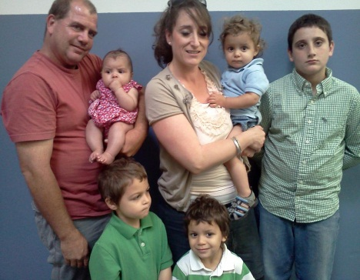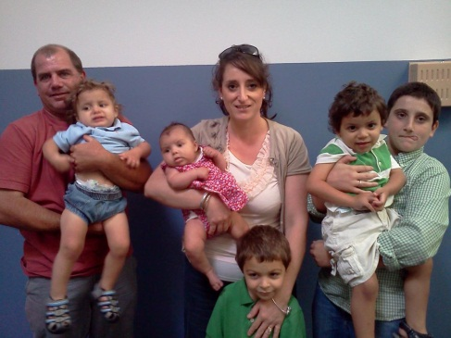
A note from the Rutherfords: In the end of May, one of the families we've been trying to work with for the past 4 years, unfortunately, found themselves in a position where the state deemed it necessary to remove the children from the home. When this happened we decided to bring the four children, ages 5, 2, 17 months, and 3 months, into our home to make sure that these siblings weren't separated by the state.
Needless to say, its been a very busy past 4 weeks, but the children are adjusting wonderfully, and are doing great. The Lord has been answering prayers and providing for the needs of these children, and we have truly been blessed by having them in our home. The oldest boy, Giovanni, has done an amazing job of learning how to use the big boy potty (Thank you Lord!!) and rarely has accidents anymore. Our little early bird, Alejandro, still insists on climbing out of bed around 5:00 AM, but we're working very patiently on that. Angel, our 17 month old...well...let’s just say that we have very lovingly nicknamed him the town crier (and for good reason), but he's soooo very cute that you can't possibly get upset with him. And little Miss Brenda named after my wife, Brenda, has been working very hard at trying to sleep through the night for us, but hasn't quite gotten there yet.
We are currently going through the process of becoming licensed foster parents and going through that process has proven to be more demanding than caring for the children, but thanks to lots of help from many good friends we've been keeping up with the states demands as well.
One of the biggest obstacles we have come across is transportation, now that we've more than doubled the size of our family overnight, whenever we want or need to go anywhere it requires taking two vehicles, so if anyone knows of a very reasonably priced vehicle with third row seating please let us know...in the Lords service.

UPDATES ON MOMS AND BABIES:
This is Cano who just turned ten years old. He is
going into the fifth grade and is an honor student.
He is one of four children and his mother is so thankful to
God that she chose life for him!

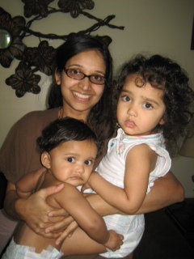
On the left is Destin and his mother Mia who had a birthday and turned nine years
old. He loves karate! His prayer is to meet his Daddy
someday. Pray for him and his mom.
On the right is one of the moms that changed her mind a year ago with her cute ten month
old son and her daughter. She is a stay at home mom and her husband works
hard to keep her home! PTL

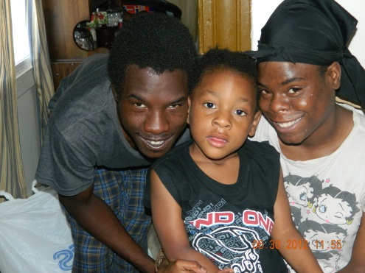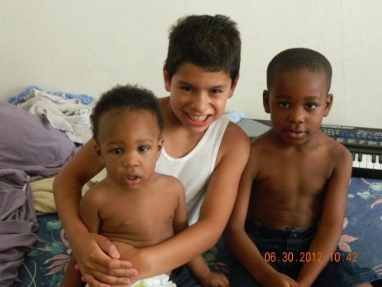
This is Gera and Kendall with her cousin. They are both twenty. We met them on June 15. This couple changed their mind after a big struggle with Gera's grandmother that was pressuring her to have an abortion. Thank God Kendall came up to us first because he didn't agree with the grandmother. He doesn't have a job and wanted to know how we can help him. On June 27 Kelly and Isaac took Kendall and Gera to the library to help them get a library card. He was able to use the library computer to fill out an application for a job at Target. Isaac was able to encourage Gera to put God first and seek His blessing by getting married and putting Him first in their lives. This couple needs our prayers for a job and direction. On Saturday Danny, Tom, Daniel and Marilyn brought them furniture that Ilka gave to us. We had a good time of fellowship with them. They are very grateful and are in need of an air conditioner right now if you have one. On the right is Daniel with Jaiquin (saved baby) and Arnaz (his brother). We brought them furniture too. Their mom Britney needs a job. They can also use a fan for their apartment. Thanks.
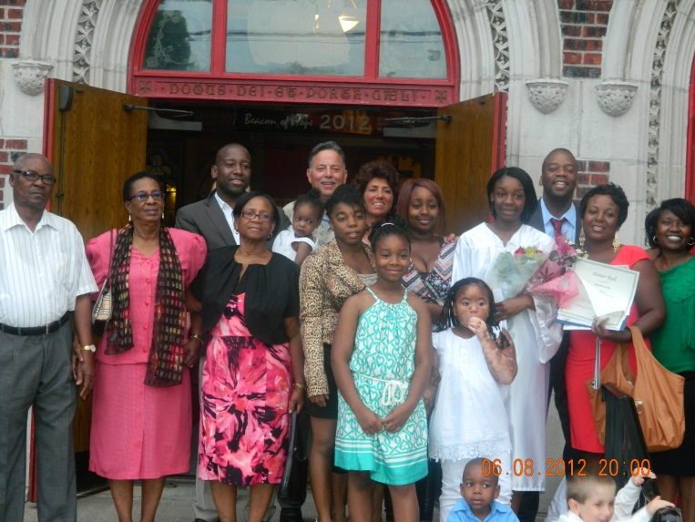
Here is the Gordon family. Hannah (13), Marilyn’s godchild, graduated from 8th grade at St Ann’s School in Black Rock, Bridgeport on June 8. She is an honor student and received many awards, we are so proud of her. We met her mom Farah many years ago when she was pregnant with Samantha (now 20) who is between Marilyn and Hannah in the photo. We have been very close to this family for twenty-one years. They are a Christian family and have seven beautiful children!
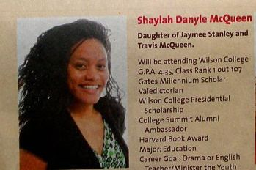
This is Shaylah, a mom that loves the Lord and her son AJ, a saved baby who is now two years old. She graduated from Hillhouse High School in New Haven on June 19 as valedictorian of her class. She received a full scholarship to a college.
On Tuesday June 12 one of the old doormen from Summit approached Carmen and asked if she remembered him. He reminded her that we helped him
find a job ten years ago as a chef at Burger King. Marshall was with his sixteen year old son Isaiah. He was willing to let the new door man know that we helped him find a job back then and that he was happy that he was able to quit his job at Summit! We have seen so many doormen quit because of the power of
prayer. God always answers our prayers!! PTL
We just found out that the Summit gives out pills for medical abortions between 8 AM- 1 PM on the days they are open. Please pray that God will close this death camp down! .
One of the moms we helped years ago is now a patrol officer. She just called us to disciple a young lady that wants to turn her life around. Please pray for Toni. Nancy and Jennie are working with her at Lighthouse Church, Bridgeport.
.
This is Terry Helfrich in the middle with Ilka and Bob. She is having heart surgery on July 10 at Bridgeport Hospital. Please keep her in your prayers. She adopted five children and comes out to the mill every week to pray and give her testimony. She is a lovely lady.
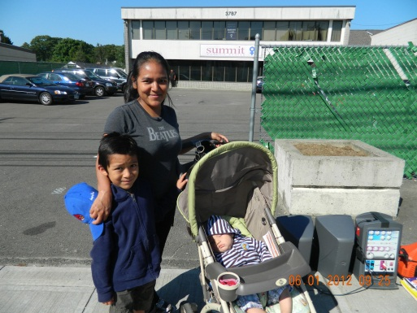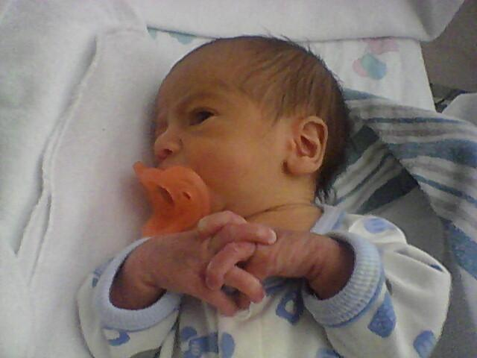
This is Maria, another mom we help out that comes to visit us at the Summit. On the right is Javen, Daisy’s baby, another child spared from death at the mill.
Hundreds of pro-life Christians came out on June 8th to the New Haven green to stand up for religious freedom. This was a nationwide rally held at many sites in all the states. Above is Danny, Vinny, Marilyn, Carmen and Pam.
“We hold these truths to be self-evident, that all men are created equal, that they are endowed by their Creator with certain unalienable Rights, that among these are Life, Liberty and the persuit of Happiness.”
Declaration of Independence of the United States of America
RIGHTS ARE BESTOWED BY GOD, NOT GOVERNMENT!
PLEASE keep OSA-CT in your prayers. Twelve of us will be going to our OSA National Event July 22-28 so please keep us in prayer. We also need coverage at the Summit the days we are not here: Tuesday, Wednesday and Friday 8 AM - 10 AM (July 17, 18, 20). If you can do this, please let us know.
This week they are only open Tuesday and Friday because of July 4th.
NEEDS: as always diapers, wipes, Stop & Shop food cards, fan, air-conditioner.
OSA-CT, 632 Merwin Ave. Milford, CT 06460-3820

